Functional Specification

**Project Symphony Drop 2:**

**Billing Transformation, Correspondence Letter,**

**and Policy Matters Modules**

**Version 0.2**

# Revision Summary

|  |  |  |  |  |
| --- | --- | --- | --- | --- |
| Version No. | Date | Revision Description | Author(s) | Approver(s) |
| 0.1 | 27/03/2019 | Initial document based on URS listed below:   * UR General Requirements v.2.0.docx * UR Project Symphony_General Requirements v2.0.docx * UR for Project Symphony_Premium and Admin Fee BillingV2.docx * UR for Bill Revamping_AHS_V2.0.docx * UR - SOA - Billing transformation ver 5.3.docx * User Requirement for Project Symphony _ AHS_ClaimModule_Addendum2.docx * UR for Project Symphony_Correspondence Letter_V2 10.docx | Nurul Iman |  |
| 0.2 | 10/9/2019 | Updated document per comments from FSD Walkthrough with IT teams (ESB, G400, SP, Staging Service, Email Service and Imaging DB). | Nurul Iman |  |

# Approval / Signoff

|  |  |  |  |
| --- | --- | --- | --- |
| Approver name and title | Function or Department | Signature or Email attachment | Signoff date |
| Sandeep Nottath Nair | CS Strategy/ CSD |  |  |
| Ernie Hee | HOD/ AHS |  |  |
| Choo Siew Wan | HOD/ AHS |  |  |
| Lim Kum Foong | CS Credit Control |  |  |
| Tan Kean Hong | IT Lead - Front End |  |  |
| Wong Jian Ming | IT Lead - Back End |  |  |

# Distribution List

|  |  |
| --- | --- |
| **Company / Department** | **Person / Group** |
| Project Lead | Eng Mei Keen |
| CS Strategy/ CSD | Sandeep Nottath Nair |
| HOD/ AHS | Ernie Hee |
| HOD/ AHS | Choo Siew Wan |
| CCU | Lim Kum Foong |
| CCU | Tan Hwei Jen |
| CS-CSPPM | Fong Yin Cheng |
| CMX | Wong Wan Siong |
| CMX | Chan Lai Foong |
| AHS | Zainatul Ashikin Kamal Sabri |
| AHS | Lim Chian Chian |
| CMX - MiCare | Muthamah Maddacanno |
| CMX - MiCare | Suziyana Abdul Karim |
| IT Lead – Front End | Tan Kean Hong |
| IT Lead – Back End | Wong Jian Ming |
| BA – Back End | Madhan Kumar |
| IT SME – G400 | Wong Jian Ming |
| IT SME – ESB | Sharon Diana Saldanha |
| IT SME – SP | Gaurav Kumar |
| IT SME – Backend Services | Srinivasa Rao Pamidimukkala |
| IT SME – Bicor | Chang Chee Wun / T.Komalavalli / Wong Choon Keat |
| IT SME – Email Gateway | Chang Chee Wun / Nik Fariz Nik Mohamed Noor |
| IT SME – Case360 | Chang Chee Wun / Nik Fariz Nik Mohamed Noor / Mohammad Azlan Yusof |

**Table of Contents**

Revision Summary 2

Approval / Signoff 3

Distribution List 4

1 Objective 7

2 Scope 7

2.1 In Scope 7

2.2 Out Scope 7

3 Current processing 7

4 Business Flow Diagram 8

5 Assumptions, dependencies and constraints 8

5.1 Assumptions 8

5.2 Dependencies 8

5.3 Constraints 8

6 Requirement trace index 9

7 Detailed functional descriptions 10

7.1 FR-001: Billing Overview 10

7.1.1 Retrieve Authorized Policy List 11

7.1.2 Retrieve Authorized Company List 12

7.1.3 Search & View Billing Document 12

7.1.4 Generate & Download Billing Document 13

7.1.5 Billing Document Type and Document Name 14

7.1.6 Downloaded Billing File Name Format 15

7.1.7 Downloaded Billing Folder Structure 16

7.2 FR-002: Correspondence Letter Overview 17

7.2.1 Retrieve Authorized Policy List 18

7.2.2 Retrieve Authorized Company List 18

7.2.3 Search & View Correspondence Letter 18

7.2.4 Generate & Download Correspondence Letter 20

7.2.5 Correspondence Letter Document Type and Document Name 21

7.2.6 Downloaded Correspondence Letter File Name Format 22

7.2.7 Downloaded Correspondence Letter Folder Structure 23

7.3 FR-003: E-Notification 23

7.3.1 Email Notification 23

7.4 FR-004: Policy Overview 24

7.4.1 Retrieve Authorized Policy List 25

7.4.2 Retrieve Authorized Company List 25

7.4.3 Search & View Policy Listing 26

7.4.4 Retrieve Authorized Policy Period List 27

7.4.5 View Policy Details 27

7.4.6 Retrieve Policy Documents 27

7.4.7 Download Policy Document 28

7.4.8 Downloaded Policy Document File Name Format 29

7.4.9 Downloaded Policy Folder Structure 29

7.5 FR-005: Internal Portal 30

7.5.1 Search and View Billing Documents, Correspondence Letters and Policy Documents on AIA Internal Portal 30

7.5.2 Download Billing Documents, Correspondence Letters and Policy Documents via AIA Internal Portal 30

8 Data requirements 30

9 Other requirements 31

10 Testing consideration 31

11 Interface consideration 31

12 Conversion consideration 31

12.1 Policy Type Criteria 31

12.2 Policy Status Criteria 32

13 Reference 33

13.1 Reference Documents 33

13.2 Systems Reference 33

13.3 Acronyms 34

14 Appendix 34

14.1 Sample E-notification for Registered User 34

14.2 Sample E-notification for Un-registered User 34

14.3 Wireframes 34

14.3.1 Billing Wireframes 35

14.3.2 Correspondence Letter Wireframes 35

14.3.3 Policy Listing Wireframes 36

14.3.4 Policy Details Wireframes 37

# Objective

This document outlines the functional specifications of the intermediate systems for Project Symphony Drop 2 Billing Transformation, Correspondence Letter and Policy Matters modules on the My AIA Corporate portal.

My AIA Corporate portal is a self-service portal that allows user to perform employee benefit related task without having to contact the call center for information.

This document does not include any details of processes, validations or data mapping that happens on portal and source systems. The details on portal and source system are covered in separate documents.

# Scope

## In Scope

|  |  |  |
| --- | --- | --- |
| No. | Sub-Modules | Features |
| 1 | Billing Overview | * Search and view billing document records. * Download billing documents. |
| 2 | Correspondence Letter Overview | * Search and view correspondence letter records. * Download correspondence letters. |
| 3 | E-notification | * To inform clients and intermediaries of important bills and letters generated and let them self-service via MyAIA Corporate portal. |
| 4 | Policy Overview | * Search and view policy details. * View subsidiary info. * Download policy documents. |
| 5 | Internal Portal | * Document Search and Download screen for AIA staff |

## Out Scope

|  |  |  |
| --- | --- | --- |
| No. | Sub-Modules | Remarks |
|  |  |  |

# Current processing

Please refer to **Section 1** from the **UR Project Symphony_General Requirements v2.0**.

# Business Flow Diagram

The flow diagrams are separated by sections and are shown in each section before the functional descriptions.

The batch process flow will be as below. This is applicable for bills and correspondence letters.



# Assumptions, dependencies and constraints

## Assumptions

|  |  |
| --- | --- |
| **No.** | **Assumptions Description** |
| 1 |  |

## Dependencies

|  |  |  |
| --- | --- | --- |
| **No.** | **Dependencies Description** | **PIC/System** |
| 1 |  |  |

## Constraints

|  |  |
| --- | --- |
| **No.** | **Constraints Description** |
| 1 |  |

# Requirement trace index

|  |  |  |  |  |  |  |
| --- | --- | --- | --- | --- | --- | --- |
| Business requirement (BR) number | Functional requirement (FR) number | Description | Online change | Batch change | Screen design | New process flow |
| **General v2.0 (Billing)**  4(i) Bill Documents Processing & Distribution [Monthly Bill]  4(ii) Bill Documents Processing & Distribution [Daily Bills] | FR-001,  FR-002,  FR-003 | * Billing Overview * Correspondence Letter Overview * E-notification | Yes | Yes | Yes | Yes |
| **Premium & Admin Fee Billing v2**  Requirement for OSC Portal (Internal) | FR-005 | * Allow AIA staff to search & view all billing documents in staff portal. | Yes | No | Yes | Yes |
| **Bill Revamping AHS v2.0**  E-notification of bills & self-service by clients/ intermediaries in Corporate Portal | FR-003 | * E-notification | No | Yes | No | Yes |
| **SOA Billing Transformation**  E-notification of bills & self-service by clients/ intermediaries in Corporate Portal | FR-003 | * E-notification | No | Yes | No | Yes |
| **Correspondence Letter v2 10**  4.1 Scope  4.2 Enrolment notification  4.3 Underwriting First Deferment Advice  4.4 Policy Documents  4.5 E-notification | FR-002 | * Correspondence Letter Overview * Allow AIA staff to search & view all letter in staff portal. | Yes | Yes | Yes | Yes |
| **General v2 30 (Policy)**  4.7 Policy Matters | FR-002 | * Policy Overview * Allow AIA staff to search & view all policy document in staff portal. | Yes | Yes | Yes | Yes |

# Detailed functional descriptions

## FR-001: Billing Overview





|  |  |  |
| --- | --- | --- |
| Business Process | Functional Descriptions | Systems |
| Retrieve Authorized Policy List  * Portal will populate the authorized policy list as one of the search criteria for billing. * The list is populated based on user’s accessibility. * The list is excluding corrupted, declined and PN policy. * For AIA Staff, the policy list will not be populated, except for Banca PD. | 1. When portal loads the billing search page, *RetrieveAuthorizedPolicy* API will be called to populate the policy no. drop down. 2. Once the API is called, ESB will:    * Retrieve all the authorized policy from G400 Datamart based on the PIC login credential.    * For intermediary and AIA PD (Banca), retrieve their previous servicing client’s policy from G400 Datamart as well.    * The list is excluding corrupted policy (Policy Corrupted = Y), declined policy (status = DC) and policy with PN status.    * The list will be sorted by policy no in ascending order.    * If failed to retrieve, then pass error message to portal.    * If no data found, then pass no record found to portal. | ESB,  SP,  Datamart |
| Retrieve Authorized Company List  * Portal will populate the authorized company list as one of the search criteria for billing. * The list is populated based on user’s accessibility. * For AIA Staff, the company list will not be populated, except for Banca PD. | 1. When portal loads the billing search page, *RetrieveAuthorizedCompany* API will be called to populate the company name drop down. 2. Once the API is called, ESB will:    * Retrieve all the authorized company from G400 Datamart based on the PIC’s authorized policy list or debtor code upon login.    * The list will be sorted by company name in ascending order.    * If failed to retrieve, then pass error message to portal.    * If no data found, then pass no record found to portal. 3. If data found, then pass the list to portal to be displayed. | ESB,  SP,  Datamart |
| Search & View Billing Document  * User can search and view billing listing via portal. * The listing will include Lapsed and Cancelled policy as well. * Refer to document type and document name here. * Document Issuance Date for each Document Type is as below.   + Premium & Admin Fee bill's Issuance Date   + ASO & ASO Claim Excess bill's Issuance Date   + Claim Excess bill's Issuance Date   + Statement of Account's Statement Creation Date * User can download claim statement from ASO & ASO Claim Excess Bill and Claim Excess Bill search result. * Refer to billing wireframes here.   Basic search criteria:   * Company name * Policy No. * Document Type (default All)   Advanced search criteria:   * Company name * Policy No. * Document Issuance Date Range (default latest 60 days) * Bill No. (n/a for SOA) * Billing Type (only for Premium & Admin Fee)   + New Business   + Renewal   + Adjustment   + Installment   Search result:   * Policy no. & policy name * Company name * Document Type * Bill No. (n/a for SOA) * Billing Type (only for Premium & Admin Fee) * Document Issuance Date * Main Document Name * Supporting Document Name (n/a for SOA) | 1. The search rules for billing are as below.    * For AIA staff, either company name or policy no. is mandatory.    * For HR and intermediary, if company name or policy no. is selected, then search up to 365 days (1 year). Else search up to 60 days. 2. Once user clicks on search button, portal will call *RetrieveBillStatementListing* API to get the billing listing. 3. Once the API is called, ESB will:    * Check the search criteria. If policy no. is not provided, then retrieve the authorized policies from the temp table.    * Then, call SP to Imaging DB to retrieve the billing based on the search criteria with pagination per rules below.      1. Retrieve record by AND condition of all search criteria      2. Use wildcard with at least 3 characters when search by Company Name.      3. Use exact value when search by Policy No. and Bill No.      4. If no document type selected, then retrieve for ALL document types.      5. If no billing type selected, then retrieve for ALL billing type.    * If failed to retrieve, then pass error message to portal.    * If no data found, then pass no record found to portal.    * If data found, then pass the listing to portal to be displayed.    * The listing will be sorted by default per below criteria (in sequence).      1. Document Issuance Date descending      2. Company name ascending      3. Policy No. ascending      4. Bill No. ascending (in order below):         1. SOA – No bill number         2. ASO & ASO Claim Excess bill – with prefix A         3. Claim Excess bill – with prefix C         4. Premium & Admin Fee bill – with prefix P         5. Takaful ASO & ASO Claim Excess bill – with prefix TA         6. Takaful Claim Excess bill – with prefix TC         7. Takaful Premium & Admin Fee bill – with prefix TP 4. If user select another sorting criteria, then ESB will repeat step (3) above, following the new sort criteria as below.    * Document Issuance Date ascending or descending    * Company name ascending or descending    * Policy No. ascending or descending    * Bill No. ascending or descending  |  |  |  |  |  | | --- | --- | --- | --- | --- | | **Sort Option** | **Issue Date** | **Company Name** | **Policy No.** | **Bill No.** | | Secondary Sort #1 | Company Name ascending | Issuance Date descending | Issuance Date descending | Issuance Date descending | | Secondary Sort #2 | Policy Number ascending | Policy Number ascending | Company Name ascending | Company Name ascending | | Secondary Sort #3 | Bill Number ascending | Bill Number ascending | Bill Number ascending | Policy Number ascending |  1. If user select another page on the search result, then ESB will repeat step (3) above. | ESB,  SP,  Imaging DB |
| Generate & Download Billing Document  * User can download the billing by:   + Select main document only.   + Select supporting document only.   + Select single or multiple billing document set from the search result.   + Bulk download for all search result in the selected page no. * The selected document will be grouped by policy no. and bill no. and consolidated into 1 zip file. | 1. Once user clicks on download button, portal will call *DownloadBillStatement* API to start the download process of the selected billing. 2. Once the API is called, ESB will:    * Check the download criteria. If policy no. is not provided, then retrieve the authorized policies from the temp table.    * Retrieve the billing from Imaging DB based on the download criteria.    * Store the download request with details into request table in Staging DB with status as Requested.    * Notify Staging Service to proceed with the file compilation. 3. Once notified, Staging Service will:    * Check the type of request.    * Retrieve the download request data from Staging DB.    * If data not found, then update the request status as Failed in Staging DB.    * If data found, then get the actual file in Imaging DB using the GUID given in SP and compile the letters into a single zip file.    * Refer to the downloaded bill name format here and folder structure of the zip file here.    * If the file compilation failed, then update the request status as Failed in Staging DB.    * If the file compilation successful, then update the request status as Success in Staging DB and store the zip file into notification table in Staging DB with file status as unread (this is for download count purposes). 4. Once the download file is ready, portal will display notification and user can download the file via the download notification or the download page. | ESB,  SP,  Imaging DB,  Staging Service |

### Billing Document Type and Document Name

The document type and document name which will be populated in billing listing are following the below sequence (first document type, then document name).

|  |  |  |
| --- | --- | --- |
| **Document Type** | **Main Document** | **Supporting Document** |
| **Premium & Admin Fee Bill** | Either One of the below:   * Invoice * Credit Note * Debit Note | Can have none or all the below:   * Billing Commission Statement * Branch, Cost Centre Summary Listing * Enrolment notification * Member Detail (Ms. Excel) * Member Detail (PDF) * Member Detail Claim * Summary Billing Statement |
| **ASO & ASO Claim Excess Bill** | Either One of the below:   * Credit Note * Debit Note | Can have none or all the below:   * Billing Statement * Pre-Employment Detailed Listing * Summary Billing Statement |
| **Claim Excess Bill** | Either One of the below:   * Credit Note * Debit Note | Can have none or all the below:   * Billing Statement * Summary Billing Statement |
| **Statement of Account (SOA)** | Statement of Account | n/a |

### Downloaded Billing File Name Format

The downloaded billing file will follow the name format below.

|  |  |  |  |
| --- | --- | --- | --- |
| **Document Type** | **Document Name** | **Downloaded File Name** | **Example File Name** |
| **Premium & Admin Fee Bill** | Invoice | <policy no>_<bill no.>_Invoice.pdf | 30001903_P123456_Invoice.pdf |
| Credit Note | <policy no>_<bill no.>_CreditNote.pdf | 30001903_P123456_CreditNote.pdf |
| Debit Note | <policy no>_<bill no.>_DebitNote.pdf | 30001903_P123456_DebitNote.pdf |
| Billing Commission Statement | <policy no>_<bill no.>_BillingCommissionStatement.pdf | 30001903_P123456_BillingCommissionStatement.pdf |
| Branch, Cost Centre Summary Listing | <policy no>_<bill no.>_BranchCostCentreSummaryListing.pdf | 30001903_P123456_BranchCostCentreSummaryListing.pdf |
| Enrolment notification | <policy no>_<bill no.>_EnrolmentNotification.pdf | 30001903_P123456_EnrolmentNotification.pdf |
| Member Detail (Ms. Excel) | <policy no>_<bill no.>_MemberDetail.xlsx | 30001903_P123456_MemberDetail.xlsx |
| Member Detail (PDF) | <policy no>_<bill no.>_MemberDetail.pdf | 30001903_P123456_MemberDetail.pdf |
| Member Detail Claim | <policy no>_<bill no.>_MemberDetailClaim.xlsx | 30001903_P123456_MemberDetailClaim.xlsx |
| Summary Billing Statement | <policy no>_<bill no.>_SummaryBillingStatement.pdf | 30001903_P123456_SummaryBillingStatement.pdf |
| **ASO & ASO Claim Excess Bill** | Credit Note | <policy no>_<bill no.>_CreditNote.pdf | 30001903_P123456_CreditNote.pdf |
| Debit Note | <policy no>_<bill no.>_DebitNote.pdf | 30001903_P123456_DebitNote.pdf |
| Billing Statement | <policy no>_<bill no.>_BillingStatement.pdf | 30001903_P123456_BillingStatement.pdf |
| Pre-Employment Detailed Listing | <policy no>_<bill no.>_PreEmploymentDetailedListing.xlsx | 30001903_P123456_PreEmploymentDetailedListing.xlsx |
| Summary Billing Statement | <policy no>_<bill no.>_SummaryBillingStatement.pdf | 30001903_P123456_SummaryBillingStatement.pdf |
| **Claim Excess Bill** | Credit Note | <policy no>_<bill no.>_CreditNote.pdf | 30001903_P123456_CreditNote.pdf |
| Debit Note | <policy no>_<bill no.>_DebitNote.pdf | 30001903_P123456_DebitNote.pdf |
| Billing Statement | <policy no>_<bill no.>_BillingStatement.xlsx | 30001903_P123456_BillingStatement.xlsx |
| Summary Billing Statement | <policy no>_<bill no.>_SummaryBillingStatement.pdf | 30001903_P123456_SummaryBillingStatement.pdf |
| **Statement of Account (SOA)** | Statement of Account | <policy no>_<debtor code>_<statement date DDMMYYYY>_StatementOfAccount.pdf | 30001903_BJNHW00_26082019_StatementOfAccount.pdf |

### Downloaded Billing Folder Structure

* The folder structure of the downloaded billing zip file will be as below.
  + Zip file: BILL&STATEMENT_<date timestamp YYYYMMDD hhmmsss>.zip
  + Primary folder: BILL&STATEMENT_<date timestamp YYYYMMDD hhmmsss>
  + Secondary folder: <policy no.>_<company name max length 25 characters; space will be replaced by dash “- “>_<bill no.>
* For example:

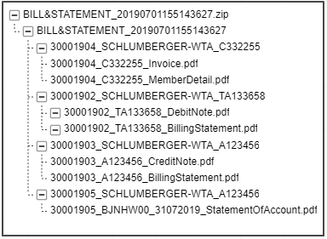

## FR-002: Correspondence Letter Overview





|  |  |  |
| --- | --- | --- |
| Business Process | Functional Descriptions | Systems |
| Retrieve Authorized Policy List  * Portal will populate the authorized policy list as one of the search criteria for correspondence letter. * The list is populated based on user’s accessibility. * The list is excluding corrupted, declined and PN policy. * For AIA Staff, the policy list will not be populated, except for Banca PD. | 1. When portal loads the correspondence letter search page, *RetrieveAuthorizedPolicy* API will be called to populate the policy no. drop down. 2. Once the API is called, ESB will:    * Retrieve all the authorized policy from G400 Datamart based on the PIC login credential.    * For intermediary and AIA PD (Banca), retrieve their previous servicing client’s policy from G400 Datamart as well.    * The list is excluding corrupted policy (Policy Corrupted = Y), declined policy (status = DC) and policy with PN status.    * The list will be sorted by policy no in ascending order.    * If failed to retrieve, then pass error message to portal.    * If no data found, then pass no record found to portal. | ESB,  SP,  Datamart |
| Retrieve Authorized Company List  * Portal will populate the authorized company list as one of the search criteria for correspondence letter. * The list is populated based on user’s accessibility. * For AIA Staff, the company list will not be populated, except for Banca PD. | 1. When portal loads the correspondence letter search page, *RetrieveAuthorizedCompany* API will be called to populate the company name drop down. 2. Once the API is called, ESB will:    * Retrieve all the authorized company from G400 Datamart based on the PIC’s authorized policy list or debtor code upon login.    * The list will be sorted by company name in ascending order.    * If failed to retrieve, then pass error message to portal.    * If no data found, then pass no record found to portal. 3. If data found, then pass the list to portal to be displayed. | ESB,  SP,  Datamart |
| Search & View Correspondence Letter  * User can search and view correspondence letter listing via portal. * The listing will include Lapsed and Cancelled policy as well. * Refer to document type and document name here. * The search result will always populate master company name even if the selected company name is a subsidiary company. But, if document name selected as Enrolment Notification, then the selected company name (regardless of master or subsidiary) will be populated. * Refer to correspondence letter wireframes here.   Search criteria:   * Company name * Policy No. * Document Issuance Date Range (default latest 60 days) * Document Type (default All) * Document Name   Search result:   * Policy no. & policy name * Company name * Document Type * Document Name * Document Issue Date | 1. The search rules for correspondence letter are as below.    * For AIA staff, either company name or policy no. is mandatory.    * For HR and intermediary, if company name or policy no. is selected, then search up to 365 days (1 year). Else search up to 60 days. 2. Once user click on search button, portal will call *RetrieveCorrespondenceLetterListing* API to get the correspondence letter listing. 3. Once the API is called, ESB will:    * Check the search criteria. If policy no. is not provided, then retrieve the authorized policies from the temp table.    * Then, call SP to Imaging DB to retrieve the correspondence letter based on the search criteria with pagination per rules below.      1. Retrieve record by AND condition of all search criteria      2. Use wildcard with at least 3 characters when search by Company Name.      3. Use exact value when search by Policy No.      4. If the selected company name if a subsidiary company, then retrieve the master company name of the subsidiary. But, if document name selected as Enrolment Notification, then use the selected company name (regardless of master or subsidiary).      5. If no date range selected, then retrieve up to latest 60 days (T till T-60).      6. If no document type selected, then retrieve for all document types.      7. If no document name selected, then retrieve for all document name.    * If failed to retrieve, then pass error message to portal.    * If no data found, then pass no record found to portal.    * If data found, then pass the listing to portal to be displayed.    * The listing will be sorted by default per below criteria (in sequence).      1. Company name ascending      2. Policy No. ascending      3. Document Type (in order below):         1. Underwriting Letter         2. Enrolment Notification         3. Termination of Policy         4. Notification of Suspension         5. Outstanding Reminder Letter         6. Payment and Refund      4. Document Issuance Date descending 4. If user select another sorting criteria, then ESB will repeat step (3) above, following the new sort criteria as below.    * Company name ascending or descending    * Policy No. ascending or descending  |  |  |  | | --- | --- | --- | | **Sort Option** | **Company Name** | **Policy Number** | | Secondary Sort #1 | Policy Number ascending | Company Name ascending | | Secondary Sort #2 | Document Type in order | Document Type in order | | Secondary Sort #3 | Document Issuance Date descending | Document Issuance Date descending |  1. If user select another page on the search result, then ESB will repeat step (3) above. | ESB,  SP,  Imaging DB |
| Generate & Download Correspondence Letter  * User can download the correspondence letter by:   + Select single or multiple document from the search result.   + Bulk download for all search result in the selected page no. * The selected document will be grouped by policy no. and consolidated into 1 zip file. | 1. Once user clicks on download button, portal will call *DownloadCorrespondenceLetter* API to start the download process of the selected correspondence letter. 2. Once the API is called, ESB will:    * Check the download criteria. If policy no. is not provided, then retrieve the authorized policies from the temp table.    * Retrieve the correspondence letter from Imaging DB based on the download criteria.    * Store the download request with details into request table in Staging DB with status as Requested.    * Notify Staging Service to proceed with the file compilation. 3. Once notified, Staging Service will:    * Check the type of request.    * Retrieve the download request data from Staging DB.    * If data not found, then update the request status as Failed in Staging DB.    * If data found, then get the actual file in Imaging DB using the GUID given in SP and compile the letters into a single zip file.    * Refer to the downloaded letter name format here and folder structure of the zip file here.    * If the file compilation failed, then update the request status as Failed in Staging DB.    * If the file compilation successful, then update the request status as Success in Staging DB and store the zip file into notification table in Staging DB with file status as unread (this is for download count purposes). 4. Once the download file is ready, portal will display notification and user can download the file via the download notification or the download page. | ESB,  SP,  Imaging DB,  Staging Service |

### Correspondence Letter Document Type and Document Name

The document type and document name which will be populated in correspondence letter listing are following the below sequence (first document type, then document name).

|  |  |
| --- | --- |
| **Document Type** | **Document Name** |
| **Underwriting Letter** | * Deferment Letter * Acceptance Letter * Declined Letter * Postponement Letter |
| **Enrolment Notification** | * Enrolment Notification |
| **Termination of Policy** | * Final Reminder Letter (-Lapsed) * Final Reminder Letter |
| **Notification of Suspension** | * Suspension Letter * Suspension Notice |
| **Outstanding Reminder Letter** | * Premium Reminder Letter |
| **Payment and Refund** | * Official Receipt * Experience Refund Letter |

### Downloaded Correspondence Letter File Name Format

The downloaded correspondence letter file will follow the name format below.

|  |  |  |  |
| --- | --- | --- | --- |
| **Document Type** | **Document Name** | **Downloaded File Name** | **Example File Name** |
| **Underwriting Letter** | Deferment Letter | <policy no.>_<issue date (DDMMYYYY)>_DefermentLetter.pdf | 30001903_23082019_DefermentLetter.pdf |
| Acceptance Letter | <policy no.>_<issue date (DDMMYYYY)>_AcceptanceLetter.pdf | 30001903_23082019_AcceptanceLetter.pdf |
| Declined Letter | <policy no.>_<issue date (DDMMYYYY)>_DeclinedLetter.pdf | 30001903_23082019_DeclinedLetter.pdf |
| Postponement Letter | <policy no.>_<issue date (DDMMYYYY)>_PostponementLetter.pdf | 30001903_23082019_PostponementLetter.pdf |
| **Enrolment Notification** | Enrolment Notification | <policy no.>_<issue date (DDMMYYYY)>_EnrolmentNotification.pdf | 30001903_23082019_EnrolmentNotification.pdf |
| **Termination of Policy** | Final Reminder Letter (-Lapsed) | <policy no.>_<issue date (DDMMYYYY)>_FinalReminderLetter (Lapsed).pdf | 30001903_23082019_FinalReminderLetter(Lapsed).pdf |
| Final Reminder Letter | <policy no.>_<issue date (DDMMYYYY)>_FinalReminderLetter.pdf | 30001903_23082019_FinalReminderLetter.pdf |
| **Notification of Suspension** | Suspension Letter | <policy no.>_<issue date (DDMMYYYY)>_SuspensionLetter.pdf | 30001903_23082019_SuspensionLetter.pdf |
| Suspension Notice | <policy no.>_<issue date (DDMMYYYY)>_SuspensionNotice.pdf | 30001903_23082019_SuspensionNotice.pdf |
| **Outstanding Reminder Letter** | Premium Reminder Letter | <policy no.>_<issue date (DDMMYYYY)>_PremiumReminderLetter.pdf | 30001903_23082019_PremiumReminderLetter.pdf |
| **Payment and Refund** | Official Receipt | <policy no.>_<issue date (DDMMYYYY)>_OfficialReceipt.pdf | 30001903_23082019_OfficialReceipt.pdf |
| Experience Refund Letter | <policy no.>_<issue date (DDMMYYYY)>_ExperienceRefundLetter.pdf | 30001903_23082019_ExperienceRefundLetter.pdf |

### Downloaded Correspondence Letter Folder Structure

* The folder structure of the downloaded correspondence letter zip file will be as below.
  + Zip file: CORRESPONDENCELETTER_<date timestamp YYYYMMDD hhmmsss>.zip
  + Primary folder: CORRESPONDENCELETTER_<date timestamp YYYYMMDD hhmmsss>
  + Secondary folder: <policy no.>_<company name max length 25 characters; space will be replaced by dash “- “>
* For example:

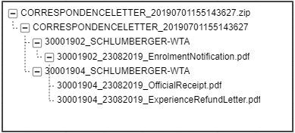

## FR-003: E-Notification

|  |  |  |
| --- | --- | --- |
| Business Process | Functional Descriptions | Systems |
| Email Notification  * System will send e-notification of bills and letters to authorized clients and intermediaries when the bills and letters are ready on portal at the end of the day. * Refer to the email template here (for activated user) and here (for non-activated user). | 1. At the end of the day, Email Service will send e-notification out to client and intermediary if the billing and letters are ready on portal. 2. The rules for sending the e-notification are as below.    * Retrieve the authorized intermediaries name and email address from G400 ZPICPF based on the debtor code.    * Trigger email notification to the intermediaries which is authorized for the debtor code.    * One debtor code can be authorized to multiple PIC; hence the e-notification could possibly be sent to multiple email addresses. 3. Print Agent will trigger the email notification once a day (at 4pm every day). 4. Once the email is triggered from Print Agent, Email Service will send the e-notification out to the authorized PIC email address. | Email Service, Print Agent |

## FR-004: Policy Overview







|  |  |  |
| --- | --- | --- |
| Business Process | Functional Descriptions | Systems |
| Retrieve Authorized Policy List  * Portal will populate the authorized policy list as one of the search criteria for policy. * The list is populated based on user’s accessibility. * The list is excluding corrupted, declined and PN policy. * For AIA Staff, the policy list will not be populated, except for Banca PD. | 1. When portal loads the policy search page, *RetrieveAuthorizedPolicy* API will be called to populate the policy no. drop down. 2. Once the API is called, ESB will:    * Retrieve all the authorized policy from G400 Datamart based on the PIC login credential.    * For intermediary and AIA PD (Banca), retrieve their previous servicing client’s policy from G400 Datamart as well.    * The list is excluding corrupted policy (Policy Corrupted = Y), declined policy (status = DC) and policy with PN status.    * The list will be sorted by policy no in ascending order.    * If failed to retrieve, then pass error message to portal.    * If no data found, then pass no record found to portal. | ESB,  SP,  Datamart |
| Retrieve Authorized Company List  * Portal will populate the authorized company list as one of the search criteria for policy. * The list is populated based on user’s accessibility. * For AIA Staff, the company list will not be populated, except for Banca PD. | 1. When portal loads the policy search page, *RetrieveAuthorizedCompany* API will be called to populate the company name drop down. 2. Once the API is called, ESB will:    * Retrieve all the authorized company from G400 Datamart based on the PIC’s authorized policy list or debtor code upon login.    * The list will be sorted by company name in ascending order.    * If failed to retrieve, then pass error message to portal.    * If no data found, then pass no record found to portal.    * If data found, then pass the list to portal to be displayed. | ESB,  SP,  Datamart |
| Search & View Policy Listing  * User can search and view policy listing via portal. * The listing will include Lapsed and Cancelled policy as well. * The search result will always populate master company name even if the selected company name is a subsidiary company. * The document name populated in policy listing are following the below sequence:   + Policy Endorsement   + Policy Contract   + Health Services Agreement (HSA)   + Addendum to HAS * Refer to policy listing wireframes here.   Search criteria:   * Company name * Policy No. * Policy Status   + Active (include Active, Suspended, Renewal in Progress status)   + Inactive (include Inactive, Expired status)   Search result:   * Policy no. & policy name * Company name * Policy Status * Document Name * Document Issue Date | 1. The search rules for policy are as below.    * For AIA staff, either company name or policy no. is mandatory. 2. Once user clicks on search button, portal will call *RetrievePolicyListing* API to get the policy listing. 3. Once the API is called, ESB will:    * Check the search criteria. If policy no. is not provided, then retrieve the authorized policies from the temp table.    * Then, call SP to Imaging DB to retrieve the policy based on the search criteria with pagination per rules below.      1. Retrieve record by AND condition of all search criteria      2. Use wildcard with at least 3 characters when search by Company Name.      3. Use exact value when search by Policy No.      4. If the selected company name if a subsidiary company, then retrieve the master company name of the subsidiary.      5. Retrieve the status of latest policy period.      6. Retrieve the latest policy documents within 60 days.      7. By default, retrieve for all policy status unless specifically selected.    * If failed to retrieve, then pass error message to portal.    * If no data found, then pass no record found to portal.    * If data found, then pass the listing to portal to be displayed.    * The listing will be sorted by default per below criteria (in sequence).      1. Company name ascending      2. Policy No. ascending 4. If user select another sorting criteria, then ESB will repeat step (3) above, following the new sort criteria as below.    * Company name ascending or descending    * Policy No. ascending or descending    * Policy Status ascending or descending  |  |  |  |  | | --- | --- | --- | --- | | **Sort Option** | **Company Name** | **Policy No.** | **Policy Status** | | Secondary Sort #1 | Policy No. ascending | Company Name ascending | Company Name ascending | | Secondary Sort #2 | Policy Status ascending | Policy Status ascending | Policy No. ascending |  1. If user select another page on the search result, then ESB will repeat step (3) above. | ESB,  SP,  Imaging DB |
| Retrieve Authorized Policy Period List  * Portal will populate the authorized policy period list upon loading for policy details page. * The list includes maximum of 4 policy period. | 1. When portal loads the policy details page, *RetrieveAuthorizedPolicyPeriod* API will be called to populate the policy period drop down based on selected policy. 2. Once the API is called, ESB will:    * Retrieve latest 4 policy periods from G400 Datamart based on the selected policy.    * The list will be sorted by policy period in descending order.    * If failed to retrieve, then pass error message to portal.    * If no data found, then pass no record found to portal. | ESB,  SP,  Datamart |
| View Policy Details  * Portal will populate the policy details once the policy is selected from the policy search result. * The policy details can be populated up to 4 policy period. * By default, latest policy period details will be populated. * Refer to policy listing wireframes here. | 1. Once user clicks on the policy from the search result, portal will call *RetrievePolicyDetails* to get the policy details and *RetrievePolicySubsidiaryList* API to get the subsidiary list. 2. Once the API are called, ESB will:    * Retrieve the policy details and subsidiary list based on the selected policy period from G400 Datamart including:      + Policy overview      + Policy general info      + Policy product info      + List of subsidiaries    * If failed to retrieve, then pass error message to portal.    * If no data found, then pass no record found to portal.    * If record found, then pass the policy details to portal.    * For policy intermediary under policy overview, retrieve the latest intermediary of the selected policy period.    * The subsidiary list will be sorted by (in sequence):      + Company Name ascending      + Policy Status ascending    * For the Outstanding details, retrieve the latest SOA from Imaging DB.    * If failed to retrieve, then pass error message to portal.    * If no data found, then pass no record found to portal.    * If record found, then pass the data to portal. 3. If user select another policy period, then ESB will repeat step (2) above, using the new policy period. | ESB,  SP,  Datamart,  Imaging DB |
| Retrieve Policy Documents  * On policy listing page, portal will populate the policy documents which are issued within the last 60 days. * On policy details page, portal will populate the policy documents once the policy is selected from the policy search result. * On policy details page, the policy documents can be populated up to 4 policy period. * By default, latest policy documents will be populated. | 1. Once user clicks on the policy from the search result, portal will call *RetrievePolicyDocument* to get the policy documents. 2. Once the API are called, ESB will:    * Retrieve the policy documents from Imaging DB which are issued within the selected policy period or the latest 60 days (based on the dates in API).    * If failed to retrieve, then pass error message to portal.    * If no data found, then pass no record found to portal.    * If record found, then pass the policy documents to portal. 3. If user select another policy period, then ESB will repeat step (2) above, using the new policy period. | ESB,  SP,  Imaging DB |
| Download Policy Document  * User can download the policy document by:   + Select single or multiple document from the search result.   + Bulk download for all search result in the selected page no. * The selected document will be grouped by policy no. and consolidated into 1 zip file. | 1. Once user clicks on download button, portal will call *DownloadPolicyDocument* API to start the download process of the selected policy. 2. Once the API is called, ESB will:    * Check the download criteria. If policy no. is not provided, then retrieve the authorized policies from the temp table.    * Retrieve the policy document from Imaging DB based on the download criteria.    * Store the download request with details into request table in Staging DB with status as Requested.    * Notify Staging Service to proceed with the file compilation. 3. Once notified, Staging Service will:    * Check the type of request.    * Retrieve the download request data from Staging DB.    * If data not found, then update the request status as Failed in Staging DB.    * If data found, then get the actual file in Imaging DB using the GUID given in SP and compile the policy documents into a single zip file.    * Refer to the downloaded policy name format here and folder structure of the zip file here.    * If the file compilation failed, then update the request status as Failed in Staging DB.    * If the file compilation successful, then update the request status as Success in Staging DB and store the zip file into notification table in Staging DB with file status as unread (this is for download count purposes). 4. Once the download file is ready, portal will display notification and user can download the file via the download notification or the download page. | ESB,  SP,  Imaging DB,  Staging Service |

### Downloaded Policy Document File Name Format

The downloaded policy document file will follow the name format below.

|  |  |  |
| --- | --- | --- |
| **Document Name** | **Downloaded File Name** | **Example File Name** |
| Policy Endorsement | <policy no.>_<issue date (DDMMYYYY)>_PolicyEndorsement.pdf | 30001903_30082019_PolicyEndorsement.pdf |
| Policy Contract | <policy no.>_<issue date (DDMMYYYY)>_PolicyContract.pdf | 30001903_30082019_PolicyContract.pdf |
| Health Services Agreement (HSA) | <policy no.>_<issue date (DDMMYYYY)>_HealthServicesAgreement.pdf | 30001903_30082019_HealthServicesAgreement.pdf |
| Addendum to HSA | <policy no.>_<issue date (DDMMYYYY)>_AddendumHSA.pdf | 30001903_30082019_AddendumHSA.pdf |

If there are more than 1 file with the same policy no., issue date and doc type, then add a running no. (starting from 1) at the end of the file name.

The file name format will be:

<policy no.>_<issue date (DDMMYYYY)>_PolicyEndorsement_<running no. starting from 1>.pdf.

For example,

30001903_30082019_PolicyEndorsement_1.pdf

30001903_30082019_PolicyEndorsement_2.pdf

### Downloaded Policy Folder Structure

* The folder structure of the downloaded policy zip file will be as below.
  + Zip file: POLICY_<date timestamp YYYYMMDD hhmmsss>.zip
  + Primary folder: POLICY_<date timestamp YYYYMMDD hhmmsss>
  + Secondary folder: <policy no.>_<company name max length 25 characters; space will be replaced by dash “- “>
* For example:

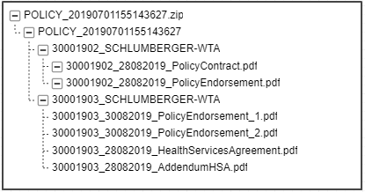

## FR-005: Internal Portal

|  |  |  |
| --- | --- | --- |
| Business Process | Functional Descriptions | Systems |
| Search and View Billing Documents, Correspondence Letters and Policy Documents on AIA Internal Portal  * AIA staff can search and view billing documents, correspondence letters and policy documents via internal portal.   Search criteria:   * Document Type * Document Creation Date range * Policy No. * Bill No. (n/a for policy documents)   Search result:   * Policy no. * Bill No. (empty for policy documents) * Document Issue Date | 1. Staging Service will:    * Add billing documents, correspondence letters and policy documents as dropdown option in View Documents page on AIA internal portal. 2. Once user clicks on search button, Staging Service will:    * Retrieve the billing documents, correspondence letters and policy documents from Imaging DB based on the search criteria.    * If failed to retrieve, then show error message on internal portal.    * If no data found, then show no record found on internal portal.    * If record found, then populate the billing documents, correspondence letters and policy documents list on internal portal. | Staging Service,  Imaging DB |
| Download Billing Documents, Correspondence Letters and Policy Documents via AIA Internal Portal  * AIA staff can download billing documents, correspondence letters and policy documents via internal portal. * User can download by:   + Select single or multiple document from the search result.   + Bulk download for all search result in the selected page no. * The selected document will be grouped by policy no. and bill no. (except for policy documents) and consolidated into 1 zip file. | 1. Once user clicks on download button, Staging Service will:    * Retrieve the billing documents, correspondence letters and policy documents from Imaging DB based on the search criteria.    * If failed to retrieve, then show error message on internal portal.    * If retrieve successful, then compile the documents and letters into a single zip file for multiple documents. | Staging Service,  Imaging DB |

# Data requirements

Data mapping will be in a separate excel file which covers mapping between portal to ESB and ESB to G400, Case360 and Imaging DB (Backend Systems).

# Other requirements

Not applicable.

# Testing consideration

Test cases will be created by the Business User after the requirements’ freeze period, which will be later than this FSD completion. Hence it will not be included in this document.

However, the test cases are necessary during the technical design to ensure that the development covers all test scenarios.

# Interface consideration

Not applicable.

# Conversion consideration

## Policy Type Criteria

|  |  |  |  |
| --- | --- | --- | --- |
| No. | Portal View | G400 Value | ESB Logic |
| 1 | Conventional | Company 3 | Check field CHDRCOY, where Company 3 = Conventional |
| 2 | Takaful | Company 4 | Check field CHDRCOY, where Company 4 = Takaful |

## Policy Status Criteria

|  |  |
| --- | --- |
| **Step 1: ESB Logic** | |
| 1. Exclude Policy Corrupted = Y and Declined policy in G400. | |
| 1. If G400 status = PN, return status as “**New Business In Progress**”. 🡪 excluded from portal 2. If G400 status = PR, return status as “**Renewal In Progress**”. 3. If G400 policy status = PN or PR, Check in G400 TM99V, if the policy found in that table with valid flag = Y, then status is **Suspended**. 4. If G400 status = LA or CA, return status as “**Inactive**”. | |
| 1. If G400 status is IF or PE and Policy Inactive indicator is not “Y”, then check in Case360 using logic below. | |
| **Step 2: Case360 Logic** | |
| **POS** | **Renewal** |
| 1. Check latest Active, Closed/ Completed cases for Non-adjustment with policy termination box checked only. 2. Renewal Billing adjustment user not null only. 3. If found, compare the effective date <= today return status “**Inactive**”. 4. If found, compare the effective date > today return status “**Active**”. | 1. Check latest Active, Closed/ Completed cases and renewal adjustment user not null only. 2. If found and tick lost, Case360 PolicyFrom date <= today, return status “**Expired**”. 3. If found and tick lost, Case360 PolicyFrom date > today, return status “**Active**”. 4. If found and untick lost, Case360 PolicyFrom date > G400 PolicyTo date, return status “**Renewal In Progress**”. 5. If found and untick lost, Case360 PolicyFrom date <= G400 PolicyTo date, then check:    1. If G400 date <= today, then return “**Expired**”    2. If G400 date > today, then return “**Active**” |
| 1. If cases found in both type, take the latest case. 2. If cases NOT found in both type (POS and Renewal), and:    1. If G400 date <= today, then return “**Expired**”    2. If G400 date > today, then return “**Active**” 3. If status is null from Case360, then check:    1. If G400 date <= today, then return “**Expired**”    2. If G400 date > today, then return “**Active**” | |
| **Step 3: ESB Logic** | |
| 1. If policy status is **Active** from case360, Check in G400 TM99V, if the policy found in that table with valid flag = Y, then status is **Suspended**. | |

# Reference

## Reference Documents

|  |  |  |
| --- | --- | --- |
| **No.** | **File Name** | **File Description** |
| 1 | User Access Matrix_V6 10_20181221.xlsx | User Access Matrix. |
| 2 | UR Project Symphony_General Requirements v2.0.docx | User Requirement for General (Billing Transformation). |
| 3 | UR for Project Symphony_Premium and Admin Fee BillingV2.docx | User Requirement for Premium and Admin Fee Billing. |
| 4 | UR for Bill Revamping_AHS_V2.0.docx | User Requirement for Bill Revamping. |
| 5 | UR - SOA - Billing transformation ver 5.3.docx | User Requirement for SOA. |
| 6 | UR for Project Symphony_Correspondence Letter_V2 10.docx | User Requirement for Correspondence Letters. |
| 7 | Addendum for General URS_V2 00.docx | User Requirement for Policy Matters. |

## Systems Reference

|  |  |
| --- | --- |
| **Application** | **Scope of Work** |
| ESB | Average of 80~100 new APIs to be created, for transactions & pulling data |
| Staging Services | Creation of new ones to facilitate real-time transactions between portal & backend |
| CPF | Enhancements to manage account/profile creation & role management |
| G400 | Enhancements to process real-time transactions from Portal |
| G400 MIMIX | Real-time replication of G400 database which can fulfilled the real-time request for MY AIA Corporate |
| Medi-Connect | Enhancement to pulling the claims info for MY AIA Corporate |
| Case 360 | Enhancement to pulling the Policy info for MY AIA Corporate |
| Callidus | Enhancement to pulling the Agent Hierarchy for MY AIA Corporate |
| CRM | Enhancement to pulling the claims info for MY AIA Corporate |
| Bicor/Print Agent | Enhancement to pre-generate all the Claims, Policies and Billing Documents for My AIA Corporate |
| Email Gateway | An Email Gateway allowed the scheduled service to massage the data and send all email notifications |

## Acronyms

|  |  |
| --- | --- |
| **Acronyms** | **Descriptions** |
| ESB | Enterprise Service Bus |
| AMSC | AIA MyService Corporate |
| CPF | Core Portal Framework |
| CRM | Enhancements to process real-time transactions from Portal |
| API | Application Programming Interface |
| AEM | Adobe Experience Manager |
| Portal | MyAIA Corporate Portal |

# Appendix

## Sample E-notification for Registered User

The email template for the e-notification will be as per attached email below.



## Sample E-notification for Un-registered User

The email template for the e-notification will be as per attached email below.



## Wireframes

The wireframes can be accessed via the URL: <https://projects.invisionapp.com/share/3MSQPXN6GKA#/screens/370203235>

### Billing Wireframes

The billing wireframes are as below.

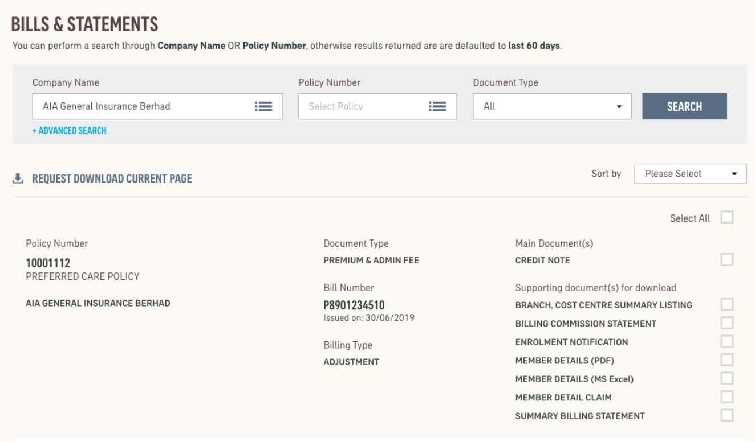

### Correspondence Letter Wireframes

The correspondence letter wireframes are as below.

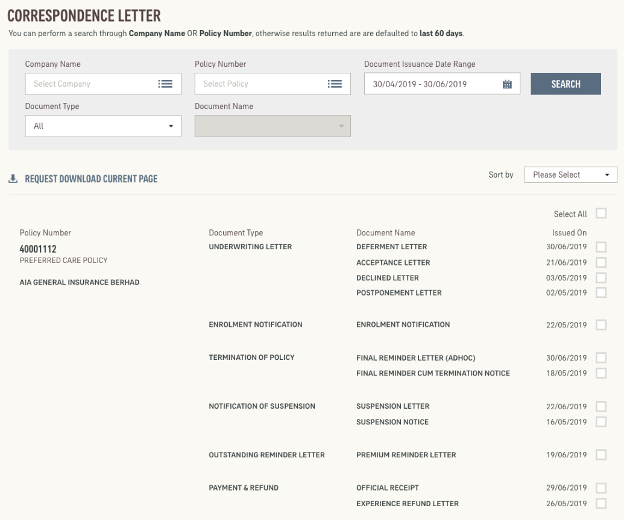

### Policy Listing Wireframes

The policy listing wireframes are as below.

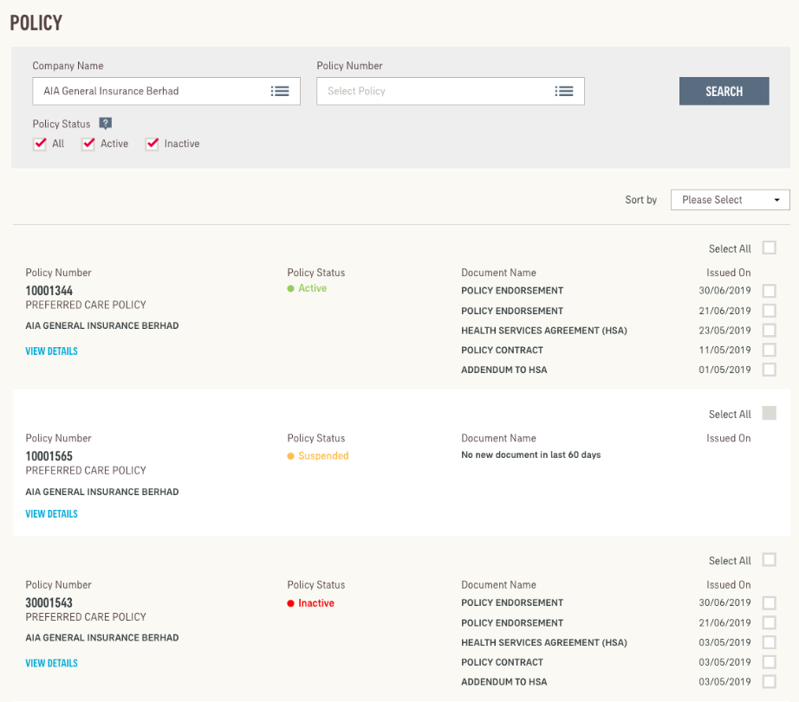

### Policy Details Wireframes

The policy details wireframes are as below.

